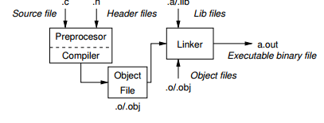
C NOTES

C language
- low-level programming language (direct calls of OS services, direct access to registers and ports)
- system programming language, for embedded (vestavěné) systems

COMPILATION
Source Code
- written in text files
- each executable program must have main() method
- header files
  - suffix .h #include <filename.h> / “filename.h”(for current directory)
  - modularity -declares a visible interface
  - provides way how to share defined macros, extern variables and use functions defined in other modules (source files) and libraries
- source files
  - suffix .c

Compilation
- executed by the program (preprocessor, compiler, linker) clang x gcc in 3 steps
gcc – GNU Compiler Collection
clang – C language family frontend for LLVM
- runnable form (standard naming a.out)

- Preprocessing
  - utilizes its own macro language (commands with the prefix #)
  - include all the header files into a single source file, replace #defines, conditional compilation #if #ifndef...
  - adjust compilation the environment
clang -E program.c
#define #include #ifdef, ifndef, if, else, elif, endif #error, #pragma
- Compilation
  - into assembly language program (program that could be translated into binary)
    - suffix in UNIX .s in MS-DOS .ASM
  - into an object file
= combination of machine language instructions, data and information needed to place instructions properly in memory
    - contains object file header, static data segment, text segment (machine language code), relocation information, symbol table (remaining labels that are not defined – external references), debugging information
    - suffix in UNIX .o in MS-DOS .OBJ
    - native (machine) readable code - bytecode
  - clang -c program.c -o program.o

- Linking
= combining independently assembled machine language programs (object files) and resolves all undefined labels (referenced libraries) into an executable code
  - LDD (List Dynamic Dependencies)
= Unix utility (shall script) that prints the shared libraries required by each program
    - suffix in UNIX .a in MS-DOS .lib for statically linked libraries
    - suffix in UNIX .so in MS-DOS .dll for dynamically linked libraries
  - executable files are tied to C library and OS services
    - suffix in UNIX .out in MS-DOS .exe

  - clang program.o -o program
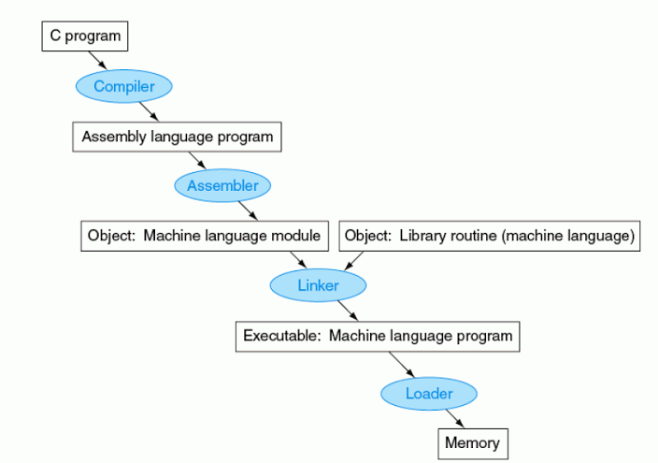

- Loading
  - reading the executable file header (determine size and data segments)
  - create an address space large enough
  - copies the instructions from the exe file into memory
  - copies parameters to the main program onto stack
  - initializes the machine registers and sets the stack pointer to the first free location
  - jumps to start-up routine that copies the parameters into the argument registers and calls the main routine of the program
- when the main routine returns the start-up routine terminates the program with the exit system call

- Dynamic linked libraries
disadvantages of statically linked libraries
- if a new version of the library is released that fixes bugs, the statically linked program keeps using the old version
- loads the whole library even if all of the library is not used when the program is run
- library routines are not linked and loaded until the program run
- both program and library routines keep extra information on the location of nonlocal procedures
- lazy procedure linkage version - each routine is linked after it is called (dynamic linker remapping DLL routines)

EXPRESSIONS IN C
- literals, variables, constants, operators, function calling, brackets

6 STANDARD LITERALS/DATA TYPES
- integer
  - stored as one of the integer type (int, long, short, char +signed/unsigned)
  - suffix U or u for unsigned, suffix L or l for long, LL for long long
    - signed int (4 bytes <-2,147,483,648, 2,147,483,647>)
    - unsigned int (4 bytes <0, 4,294,967,295>)
    - char (1 byte <-128,127>)
    - signed short (2 bytes <-32,768, 32,767>)
  - the exact size is not defined by the C norm but by the implementation → particular size of the integer data types can be specified by the data types defined in the header file <stdint.h> int8_t, int32_t, uint8_t, uint32_t

- rational
  - can be written with floating point 13.1 or with mantissa 31.4e-3
  - follow IEEE-754-1985
  - stored as one of the rational type (double, float, long double)
  - suffix F or f for float, suffix L or l for long double
    - float (4 bytes)
    - double (8 bytes)
- characters
  - ASCII (American Standard Code for Information Interchange)
  - value of the single character is the code of the characters
  - TYPE: character constant is the int type
  - escape sequences
    - \n new line character
    - \t tabulator character
    - \b backspace
    - \r carriage return
- strings
  - sequence of character and control characters (escape sequences \n \b \r…) enclosed in quotation marks
  - array of the type char terminated by \0 null - reserved for the end
    - compiler automatically adds the null character
  - can be subscripted char c = “abc”[1];
  - immutable – changing may cause undefined behavior x array of chars
  - problems with scanf
    - reading more characters than the size is could overwrite other variables
- enumerated
- symbolic constant #define
  - macro commands, established by the preprocessor
  - does not have type
  - preprocessor performs the text replacement of the define constant by its value
cast
=type conversion transforms value of some type to the value of different type
- implicit – automatically, by the compiler for assignment ex. from int to double
- explicit – must be prescribed using the cast operator ex. from double to int

CONSTANTS
- KEYWORD const
  - compiler does not allow to set a new value to the variable
x have types in comparison with symbolic constant
VARIABLES
- global variables are accessible “everywhere” in the program x can be shadowed by a local variable of the same name, which can be solved by the specifier extern in a block

declaration specifiers:
- storage classes
  - auto
    - default storage class for local variables inside a function or block
    - allocation is performed for the declaration of local variables (on the stack), memory is released at the end of variable scope
    - stored in the Stack
  - static
    - memory space is allocated during the program start, memory is never released until exit
    - stored in the static data part of the memory
  - extern
    - extends the visibility of the variables from a module to other parts of the program
    - stored in the static data
  - register
    - define local variables that should be stored in register instead of RAM
    - can not use & operator (it does not have address)

+ dynamic allocation -not directly supported
- type quantifiers
  - const
  - volatile
    - tells the compiler not to optimize anything that has to do with the volatile variable
    - other processes can access to the variable (interrupts, threads)
  - restrict
    - pointer is the only thing that accesses the underlying object
    - eliminates the potential for pointer aliasing
- type specifiers
  - void, char, short, int, long, float, double, signed, unsigned

comma expression
for (c=1, i=0; c < 10, i< 10; c+=2, i++){}

assignment = ;
- content of the memory is not defined after allocation
- name of the variable references to the particular memory location
- value of the variable is the content of the memory location
byte order =a way how to store numbers (more byte data types) in memory
little-endian – the most used order for Intel x86 architecture
simple assignment =store the value of the variable into the memory space referenced by the variable name
- a value of the expression can be assigned only to same type
<variable> = <expression> (variable, function call, literal…)
- C is not type safe
compound assignment =short version, computing a new value of the variable from itself
<variable> = <variable><operator> <expression>
- statement is terminated by semicolomn
l-value =left side of the assignment must be memory location where the value can be stored

STANDARD OUTPUT/INPUT
- program within OS has assigned standard input stdin and standard output stdout
- getchar(), putchar()
- scanf(), printf()
- gets() reads all characters until it finds the new line character
- scanf and gets automatically adds \0 char to the end of the string
File descriptors:
stdout =standard output device
stderr =standard error device

%c char
%i %u _Bool
%i %x %o int
%f %e %g %a float
%f %e %g %a double

OPERANTS
- rational operators ==, != ...
- logical operators AND &&, OR ||, NOT !
  - if the result is defined by the left operand, the right is not evaluated
- bitwise
- have lower precedence than the arithmetic operations
- treats operands as a series of bits
  - AND x & y if x and y is equal to 1 bit by bit
= bit multiplication
  - OR x | y if x or y is equal to 1 bit by bit
  - = bit summa
  - XOR x ^y if only x or only y is equal to 1
  - NOT ~x if x is 0
  - Bitwise left/right shift x <</>>y shift of x about y bits to the left/right

uint8_t a = 4;
uint8_t b = 5;
a dec: 4 bin: 0100
b dec: 5 bin: 0101
a & b dec: 4 bin: 0100
a | b dec: 5 bin: 0101
a ^ b dec: 1 bin: 0001
a >> 1 dec: 2 bin: 0010
a << 1 dec: 8 bin: 1000
- ternary operator ? :
- cast operator =changing the type of variable runtime
- increment
  - ++x – incrementation before evaluation
  - x++ – incrementation after evaluation
i =2;
printf ("%d\n",++i); //prints 3
printf ("%d\n",i--); //prints 3

ARRAYS in C

= data structure to store a number of data values of the same type
- each element has identical size → its relative address from the beginning of the array (pointer) is uniquely defined
- elements can be addressed by the order of the element in the array
- the variable of the type array represents address of the memory space, where values are stored

“offset”=size_of_type * index_of_element_in_the_array
“address” = base address (1st_element_address) + offset

- the memory is allocated by the declaration of the array variable with the defined number of the elements of the particular size
- size of the array cannot be changed
Variable length arrays
- in C99
- memory is allocated during run-time int array[n]

Arrays as a local variable
- automatically created at the declaration at the stack and it is automatically destroyed at the end of the block (function)
- the memory is automatically allocated and released
- stack is relatively small → suitable to allocate a large array dynamically (heap memory) using pointers
Never return pointer to automatic local variable!!!

Arrays as an argument of a function
- passed as a pointer
Pointer does not carry information about the size of the array
int func(int array [][]) is not allowed
Passing:
int func(int array[][13]) the number of columns is known
int func(int array[3][3])
int func(int m, int n, array[n][m])

Multidimensional arrays
- always continuous block of memory
Pointer does not always refer to continuous block of memory???
Designated initializers
- in C99, only specific elements are initialize, others are 0
int array[3][3] = {[0][0]=1, [1][1]=1,[2][2]=1};

Declaration:
- normal way int array[3][3]
- pointer to pointer int** 2darray
- 1D array of pointers int (*array) []
Array as a pointer
Array variable is a pointer to first element of the array
- however compiler differs between them size of the array variable is the total size of the elements in array x size of the pointer is size of the address (8 bytes)

POINTERS in C
= variable which value is an address of memory location where the value of some type (another variable) is stored
- type of the data it refers int* pointer x void pointer
- empty address is defined by symbolic constant NULL (0 as well)
variables in C are not automatically initialized therefore pointers can have any address in the memory at the begining→ explicit initialization of pointers to NULL
Address operator &
- returns the address of the memory location where the value of the variable is stored
Indirect operator *
- returns the value at the address stored in the pointer variable
Indirect operator for structures ->
- returns the value at the address of the structure member stored in the pointer variable to structure

Pointer Arithmetic in C
- arithmetic operations +- are defined for pointers
- useful when the pointer refers to a continuous memory block
- could be use instead [] for arrays x internal representation is different
int a = *(i*rows + j)
Performing arithmetic on pointers that does not point to an array elements cause undefined behavior

Pointers with const
- (const int)* ptr / int const* ptr =pointer to a const variable
  - pointer can not be used to change variable
  - but the variable could be modified if it is not const variable
- int (*const) ptr =constant pointer
  - pointer can not be set to another address
- const int* const ptr =constant pointer to a const variable
  - pointer can not be used to change variable and neither to be set to another address

Pointers to functions
- function implementation is stored in the memory and as a variable we can refer to its memory location
- allows dynamically calls the function according to the value of the pointers

return_type function_name (arguments);
return_type (*pointer_to_function) (arguments);
pointer_to_function = function_name

int addInt(int n, int m) {
return n+m;
}

int (*functionPtr)(int,int);
functionPtr = &addInt;
int sum = (*functionPtr)(2, 3); // sum == 5

- function is identified (except the name) by its arguments and return value → pointer to function allows implement a dynamic link of the function call determined during the program run time = basis of polymorphism in OOP

Restricted pointers????

FUNCTIONS IN C
- no inner functions
- function names can be exported to other modules
- implicitly declared as extern (visible)
x using static =local module functions (visible only in particular module)
- arguments are local variables and are called by value

Function definition
- function declaration (header)
  - how the function can be called
- function body

Passing arguments
- function argument is passed by its value
- arguments are local variables and are allocated on the stack
- change of the local variable does not change the value of the variable (passed to the function) outside the function x passing pointer, we have access to the address of the original variable

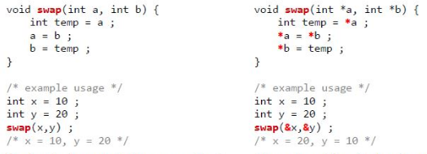
-
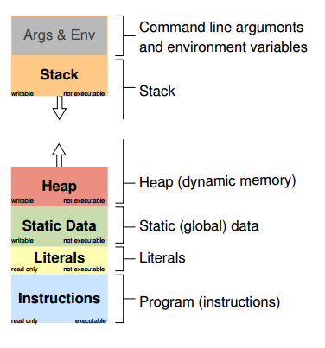
MEMORY ALLOCATION
= determination of the memory space for storing variable value

local variables – function arguments
- the memory is allocated during the function call until the function returns
- allocated from the Stack
static variables
= variables with specifier static
- preserved even after the function block ends
- stored in the static part of the memory
dynamic allocation
- library <stdlib.h> malloc () function
- allocated from the special part of the memory called Heap

Stack
- variables for the function arguments
- function call, return value and the value of the program counter is also stored to the stack
- repeated recursive function call → memory reserved for the stack can be depleted (stack overflow)

Heap
<stdlib.h>
- malloc() =allocates a block of memory but does not initialize it
  - allocation may fail → testing the return value is needed
- calloc() =allocates a block of memory and initialize it
- realloc() =resizes the allocated memory
  - does not initialize the added elements
  - if the resize is not possible it returns null pointer and the old block is untouched
  - if it is called with size 0, behaves like a free
  - if it is called with pointer NULL it behaves like a malloc
- free() - memory manager release the memory x the value of the pointer is not changed (should be explicitly set to NULL

Structures & unions
Structure
= collection of values (possibly different type) – represent records
- defined by the programmer as a new data type
- each structure has separate name space for its members

declaration:
- without tag
- has to be used with struct keyword
struct {
int number;
double value;
};record1 = {5, 0,325}, record2={.number= 6, .value= 1.44} //designed initializers

initialization:
- in declaration
- designated initializers in C99 (dot notation)
- structure tag
- has to be used with struct keyword
- the tag identifier is defined in the name space of the structure tags
struct record {
int number;
double value;
};
- using typedef
- can be used without struct keyword
- defines a global identifier
typedef struct {
int n;
double v;
} item;
- combination
typedef struct record {
int number;
double value;
} record;

copying structures:
- for simple structures the memcpy can be used (they must have same size)
- shallow copy
memcpy(&structure1, &structure2 sizeof(structure1));

size of structures:
- may differ from the sum of size all the elements
- compiler may align the data fields → it provides better performance for addressing

Union
= collection of values (possibly different type)
- members share the same storage
- only one member can contain a value at any given time
- efficient way of using the same memory location for multiple purposes
- size of the union is according to the largest member

union Nums {
char c;
int i;
};

union Nums nums;

Enumerated
= allow to define a subset of integer values and named them
- first item has without explicit definition always the value 0
- definition is similar to struct
- without typedef (enum is mandatory)
enum strategy {RANDOM, IMMEDIATE, SEARCH};
enum strategy my_strategy = IMMEDIATE;
- with typedef
typedef enum {RANDOM, IMMEDIATE, SEARCH} strategy;
strategy my_strategy = IMMEDIATE;

Macros

Conditional compilation
#if, #ifdef, #ifndef, #elif, #else, #endif

- protecting from including again the same header files
#ifndef GRAPH_H
#define GRAPH_H ...
// header file body here // it is processed only if GRAPH_H is not defined // therefore, after the first include, // the macro GRAPH_H is defined // and the body is not processed during the repeated includes ... #endif

Directives
#error //produces error message
#line //alter the way how lines are numbered (__LINE__ and__FILE__ macros)
#pragma //provides a way to request a special behaviour from the
compiler

Predefined macros
__LINE__ – Line number of the file being compiled (processed)
__FILE__ – Name of the file being compiled
__DATE__ – Date of the compilation (in the form "Mmm dd yyyy")
__TIME__ – Time of the compilation (in the form "hh:mm:ss")
__STDC__ – 1 if the compiler conforms to the C standard (C89 or C99)

NOTES FOR BASH AND LINUX FEATURES

- echo $?
= exit status of the last executed commands
- if the C program passes, returns 0 other values indicates some error
- sizeof (int/double/char)
= returns the number of bytes that are allocated for
- echo “7 4” < in ./main > in

BTW notes
31 a.out execution – need defined the environmental path export PATH=”$PATH: ‘pwd’”
stip

C practise

- input check
if (scanf("%d %d",&weight,&height)!=2){}
= check weather the input was successful
- standard error output
fprintf(stderr,"Error: Vstup mimo interval!\n");
- infinite for loop
for (;;){}

- expression value 10 x++ variable value 11
  - need more memory space
- expression value 11 ++x variable value 11
  - ++(i++)
  - - nelze, hodnota zavorky nema pamet

LVALUE

undefined behavior
- cannot compile

Bitwise operations
uint16_t i
set the 4 bit of i i & 0x0010
clear the 4 bit of I i&= ~0x0010
Bit fields structures
- save memory, allows defining the width of a variable → tells the C compiler that you are going to use only those number of bytes
typedef struct {
uint16_t seconds: 5; // use 5 bits to store seconds
uint16_t minutes: 6; // use 6 bits to store minutes
uint16_t hours: 5; //use 5 bits to store hours
} file_time_t;
file_time_t time;

- the all 3 unint16_t exist, even if we use only some bits
restriction: bit-fields does not have address and therefore using & is not allowed
- bit-fields are handle according to storage units (implementation defined 8 /16… bits)
- the name of the bit-field can be ommited for padding to ensure other fields are properly positioned

C restrict
- nedovoluji zasah

C inline
- neuklada se na Stack, primo se zpracuje

Generic
- compile time
x dynamicka vazba polymorphism - slower

